Position Statement

Mandatory Bullying and Harassment Training for Elected Members

The Australian Local Government Women’s Association WA Branch is the peak body representing the interests of women in WA Local Government. Over the last few months, we have seen a rise in accounts from our membership of incidents involving workplace bullying and harassment, especially at a Council level, often from other Elected Members.

Bullying at work, as defined by the Fair Work Act 2009, occurs when:
- a person or a group of people behaves unreasonably and repeatedly towards a worker or a group of workers while at work; and
- the behaviour creates a risk to health and safety.
However, Elected Members aren’t covered by the Fair Work Commission as they are not employees.

The Local Government (Model Code of Conduct) Regulations 2021 were implemented in 2021 with clauses specifically addressing bullying and harassment, calling on local governments to address behaviour through education rather than sanctions, but it has done little to stop this behaviour.

In response, we are calling for legislative reform to afford better protections for Local Government Elected Members affected by bullying and harassment, through mandatory Workplace Bullying and Harassment training for all Elected Members.

We acknowledge that Local Governments may already provide this training for Elected Members, however there are no regulations in place to ensure Elected Member’s attendance at such training. By incorporating this training into the mandatory training schedule and adding a penalty under the regulations, all Elected Members will be required to attend or face consequences for not attending.

We are calling on the Minister of Local Government, Sports and Cultural Industries to include mandatory Workplace Bullying and Harassment training in the Regulations, as permissible under Section 5.126 of the Local Government Act 1995.

It would require a simple amendment to Section 10 of the Local Government (Administration) Regulations 1996, by adding a new point:
(3) Additionally, each council member must complete a Workplace Bullying and Harassment course facilitated by a suitable RTO.

and renumbering the section accordingly.

Position Statement

Mandatory Bullying and Harassment Training for Elected Members

We also request that the regulations add a clause to allow a financial penalty for non-compliance with the training schedule as referenced in the Local Government Act 1995 Section 5.126 (2) (d).

(5) A person who contravenes subsection (1) commits an offence. Penalty $5,000.

Such a small change could have such a huge impact in the prevention of future workplace bullying and harassment issues.

Appendix 1:

Local Government Act 1995, Section 5.126 - Training for council members
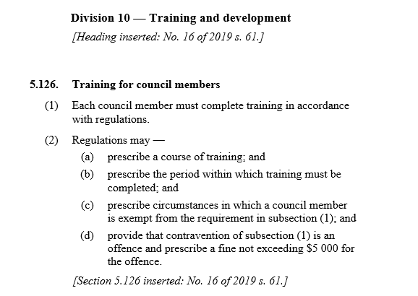

Appendix 2

Local Government (Administration) Regulations 1996, Section 10 – Training

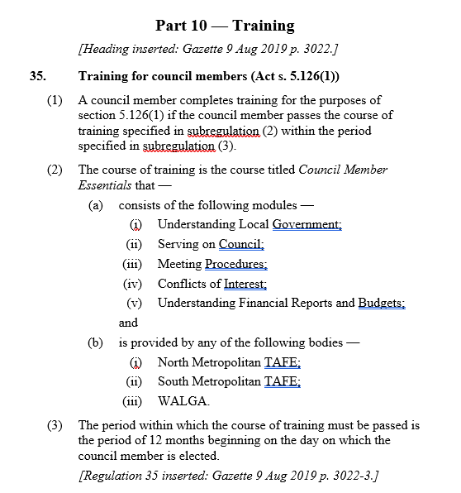

Appendix 3

Local Government (Model Code of Conduct) Regulations 2021, Section 9 – Relationship with others & Section 10 – Council or committee meetings

